User Acceptance Testing (UAT) Template
Date | 01 October 2026
Team ID | SWTID-2026-5228
Project Name | Import Data using Transform Maps (Spreadsheet)
Maximum Marks
Project Overview:
Project Name: Import Data using Transform Maps (Spreadsheet)
Project Description: Employee data received as an Excel spreadsheet is loaded into an Import Set (staging) table in ServiceNow and moved into the Employee Test table using a Transform Map. Coalesce on Employee ID updates existing employees instead of creating duplicates. The imported data is shown in reports (pie chart by department, bar chart by location, employee list) on the Employee Analytics Dashboards dashboard.
Project Version: 1.0
Testing Period: 29 September 2026 to 17 October 2026 (as per the sprint plan)
Testing Scope:
Features and functionalities to be tested:
- Creating the Employee Test table and its fields
- Uploading the Excel file with Load Data (Import Set table)
- Transform Map creation, field mapping (Auto Map and Mapping Assist) and running the transform
- Coalesce on Employee ID and the re-import duplicate check
- Validating the imported records in the Employee Test table
- Reports (Employees by Department, Employees by Location, Employee List Report) and the Employee Analytics Dashboards dashboard
User stories or requirements to be tested:
- FR-1 to FR-6 (Table & Data Setup, Data Import, Transform & Field Mapping, Duplicate Prevention, Data Validation, Reporting & Dashboard)
- User stories USN-1 to USN-14
- Not covered in this UAT: Access Control (Roles & ACL) - FR-7, USN-15 and USN-16
Testing Environment:
URL/Location: ServiceNow Personal Developer Instance (PDI), accessed through a web browser
Credentials (if required): Administrator account of the PDI (credentials are not recorded in this document)
Test Cases:
Test Case ID | Test Scenario | Test Steps | Expected Result | Actual Result | Pass/Fail
TC-001 | Create the Employee Test custom table with its fields | 1. Open Tables > Create New  2. Enter Label: Employee Test (Name: u_employee_test) and save  3. Open Form Layout and add Employee ID, Employee Name, Email, Department, Location (String) | The table is created and all five fields are visible on the Employee Test form | Employee Test form shows Employee ID, Employee Name, Email, Department and Location | Pass
TC-002 | Upload the Excel file using Load Data | 1. Prepare the sample sheet with a header row (Employee ID, Name, Email, Department, Location) and download it as .xlsx  2. Open System Import Sets > Load Data  3. Create table, Label: Employee Import (u_employee_import), choose the file, Sheet number 1, Header row 1 and click Submit | Import Set table is created and a success message is shown | State: Complete, Completion code: Success. Processed: 5, inserts 5, updates 0, errors 0, empty and ignored 0 | Pass
TC-003 | Create the Transform Map and map the fields | 1. Click Create Transform Map, Name: Sample Spreadsheet Import  2. Target table: Employee Test  3. Click Auto Map Matching Fields, then use Mapping Assist and Save | All source fields are mapped to the correct target fields | Field Maps (5): u_employee_id, u_name, u_email, u_department and u_location are mapped to the Employee Test fields | Pass
TC-004 | Run the transform | 1. Click Transform on the Transform Map  2. Select the Import Set and Transform Map and click Transform | Transform completes with a success message | Transforming ISET0010002 - State: Complete, Completion code: Success, Message: Transformation complete | Pass
TC-005 | Validate the imported records | 1. Open the Employee Test table from the Application Navigator  2. Rearrange the columns using Personalize List Columns | All imported records and columns are shown in the list view | All 5 records (SB0001 to SB0005) are shown (1 to 5 of 5) with Employee ID, Employee Name, Department, Email and Location | Pass
TC-006 | Import an updated sheet with a new employee (duplicate check) | 1. Add a new employee row (SB0006) to the Excel sheet  2. Load the sheet using Load Data and run the transform  3. Open the Employee Test table | The new employee is added and the existing employees are not duplicated | Table shows 6 records (1 to 6 of 6): SB0006 is added and SB0001 to SB0005 each appear once | Pass
TC-007 | Re-import the same sheet (duplicate check, negative scenario) | 1. Load the same Excel sheet again using Load Data  2. Run the transform with the same Transform Map  3. Open Transform History | No duplicate records are created; no rows are inserted | Transform History for the re-import (ISET0010004): State: Complete, Total 4, Inserts 0, Updates 0, Ignored 4, Skipped 0, Errors 0. No duplicate records were created | Pass
TC-008 | Employees by Department pie chart | 1. Reports > New, Table: Employee Test  2. Type: Pie chart, Group by: Department, Aggregation: Count  3. Run and Save the report | Pie chart shows the employee count for each department | Report Employees by Department was run and saved: ServiceNow = 11 (64.71%), Salesforce = 4 (23.53%), Aiml = 2 (11.76%), 17 employees in total | Pass
TC-009 | Employees by Location bar chart | 1. Reports > New, Table: Employee Test  2. Type: Bar chart, Group by: Location, Aggregation: Count  3. Run and Save the report | Bar chart shows the employee count for each location | Report Employees by Location was run and saved: Hyderabad = 16, Chennai = 1, 17 employees in total | Pass
TC-010 | Employee List Report | 1. Reports > New, Table: Employee Test, Type: List  2. Select Employee ID, Employee Name, Email, Department, Location  3. Run and Save the report | List report shows all employee records with the selected columns | Report Employee List Report was run and saved: shows 1 to 17 of 17 records with Employee ID, Employee Name, Email, Department and Location | Pass
TC-011 | Add the reports to the dashboard | 1. Create the dashboard Employee Analytics Dashboards  2. Open each report and use Share > Add to Dashboards  3. Open the dashboard | All three reports appear on the dashboard | Employee Analytics Dashboard shows all three reports: Employee List Report, Employees by Location and Employees by Department | Pass
Bug Tracking:
Bug ID | Bug Description | Steps to reproduce | Severity | Status | Additional feedback
BG-001 | No bugs recorded so far | - | - | - | -
No bugs were found in any of the test cases (TC-001 to TC-011).
Sign-off:
Tester Name: Divya Shree S (Team Leader)
Date: 01 October 2026
Signature: Divya Shree S
Notes:
- All test cases cover both positive and negative scenarios (TC-007 checks that a repeated import creates no duplicates).
- Testers are encouraged to provide detailed feedback, including any suggestions for improvement.
- Bug tracking includes details such as severity, status and steps to reproduce.
- Obtain sign-off from both the project manager and product owner before proceeding with deployment.
Test Evidence (Screenshots)
TC-001: Employee Test form with the five fields
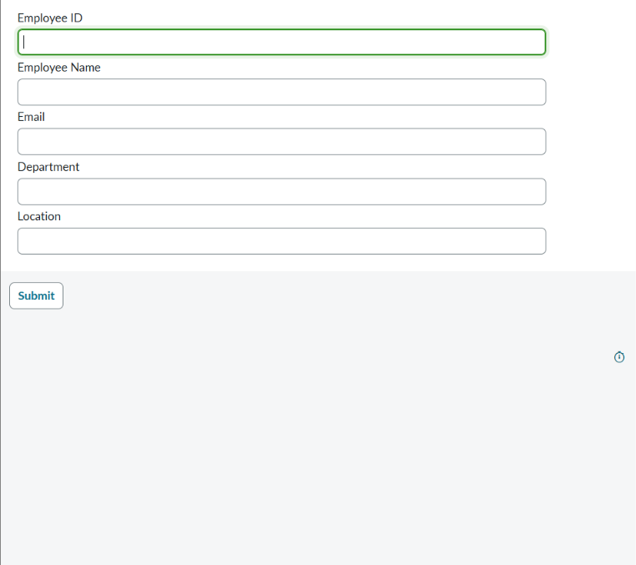
Figure 1
TC-002: Sample spreadsheet, and the Load Data success message with row counts
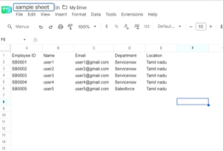
Figure 2
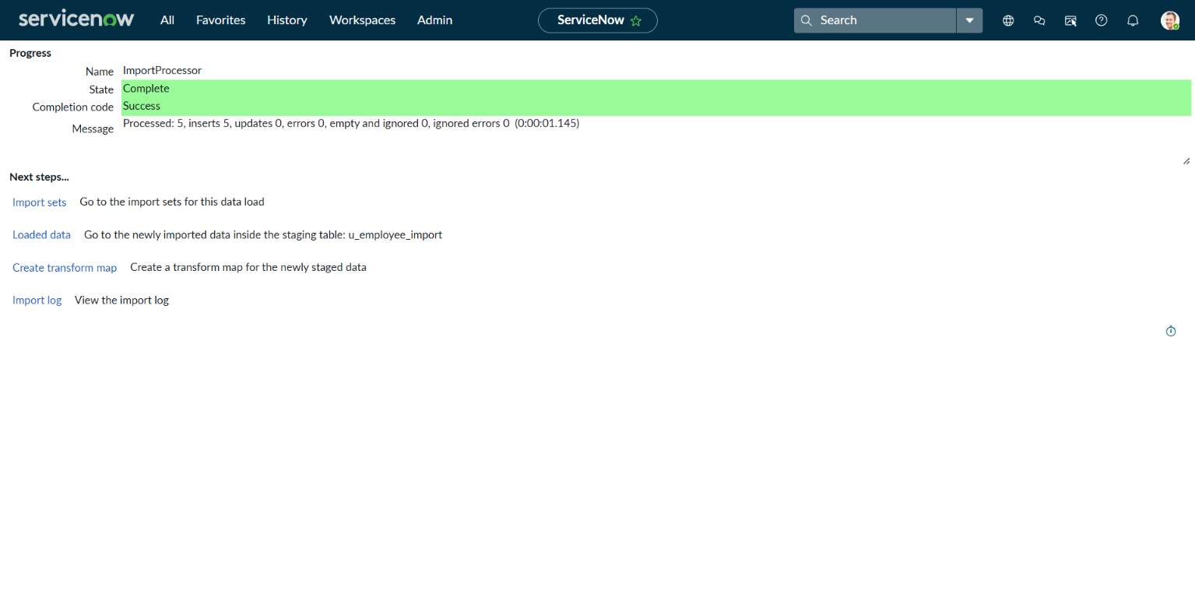
Figure 3
TC-003: Transform Map field maps (source field to target field)
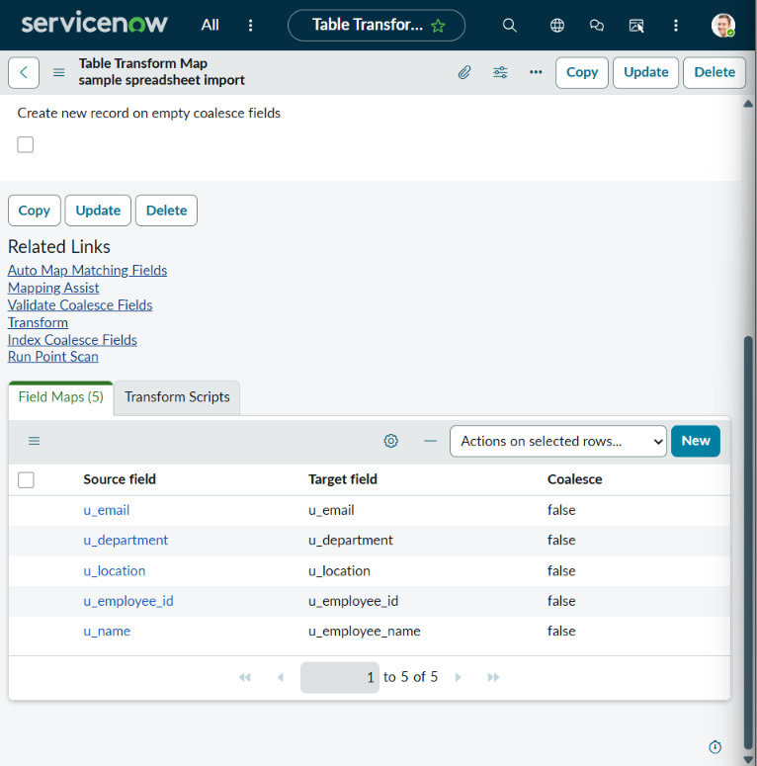
Figure 4
TC-004: Transform completed with Success
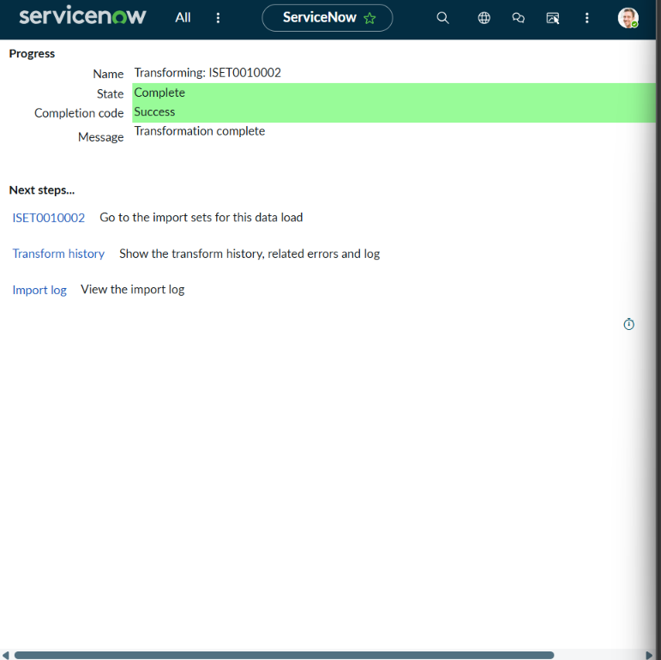
Figure 5
TC-005: Imported records in the Employee Test table (5 records)
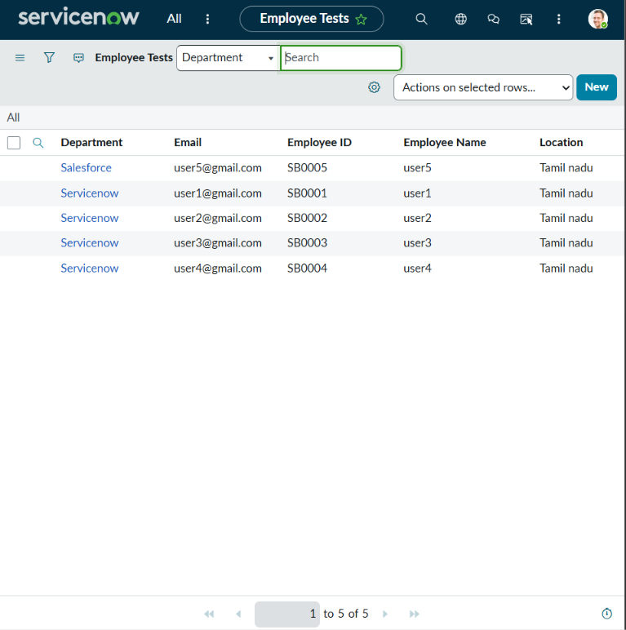
Figure 6
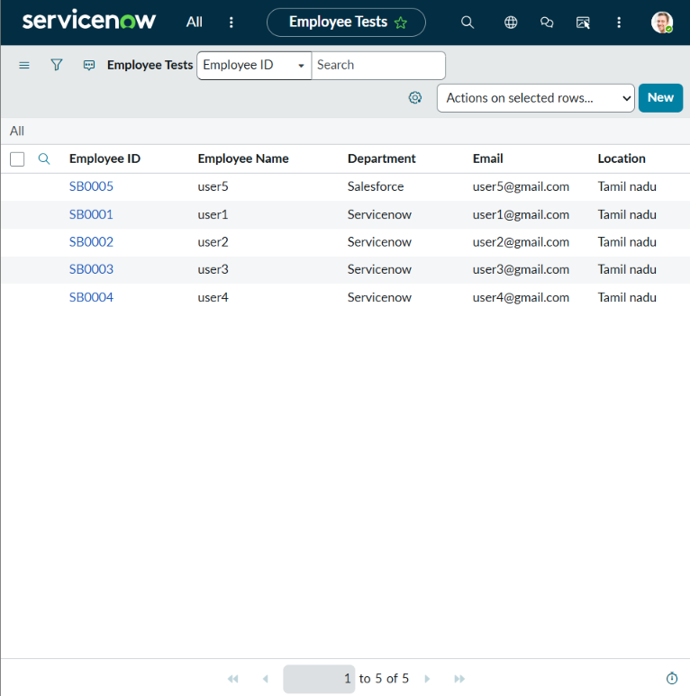
Figure 7
TC-006: Employee Test table after importing the new employee SB0006 (6 records, no duplicates)
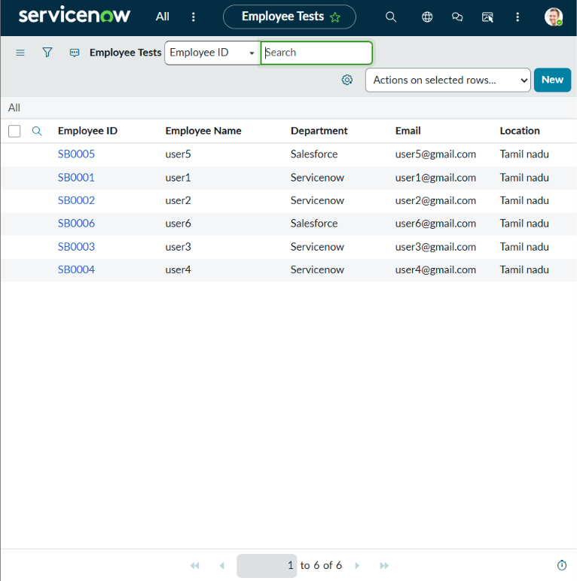
Figure 8
TC-007: Coalesce set to true on Employee ID, then the same sheet re-imported (0 inserts, 0 updates, 4 ignored)
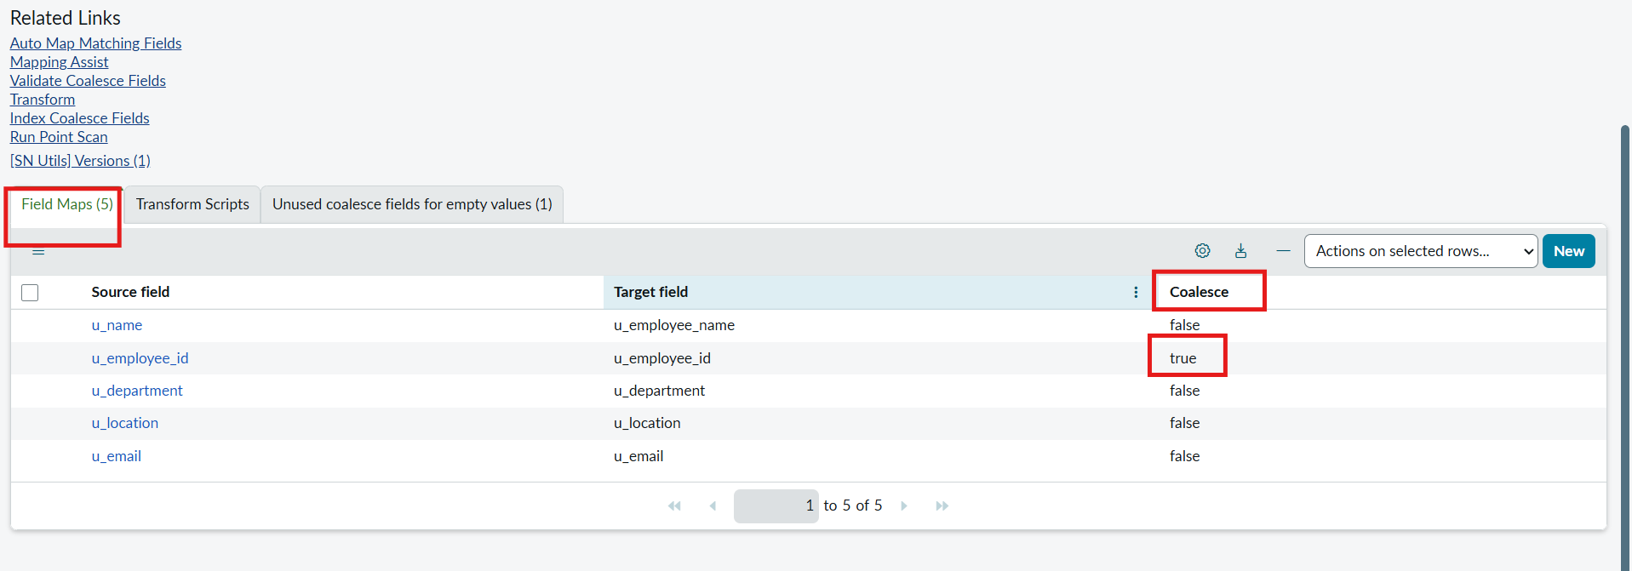
Figure 9
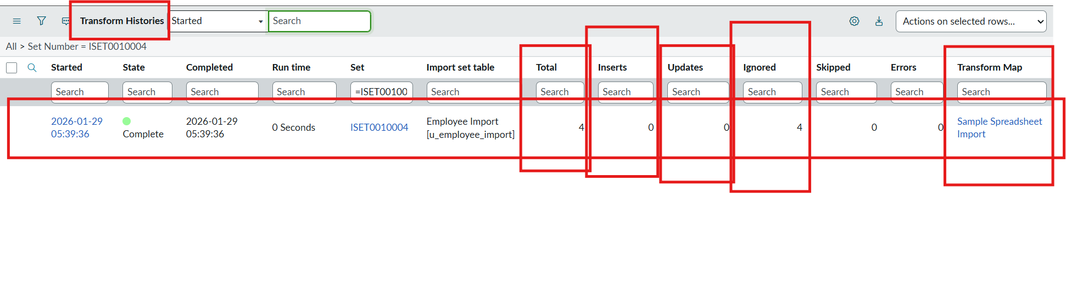
Figure 10
TC-008: Employees by Department pie chart
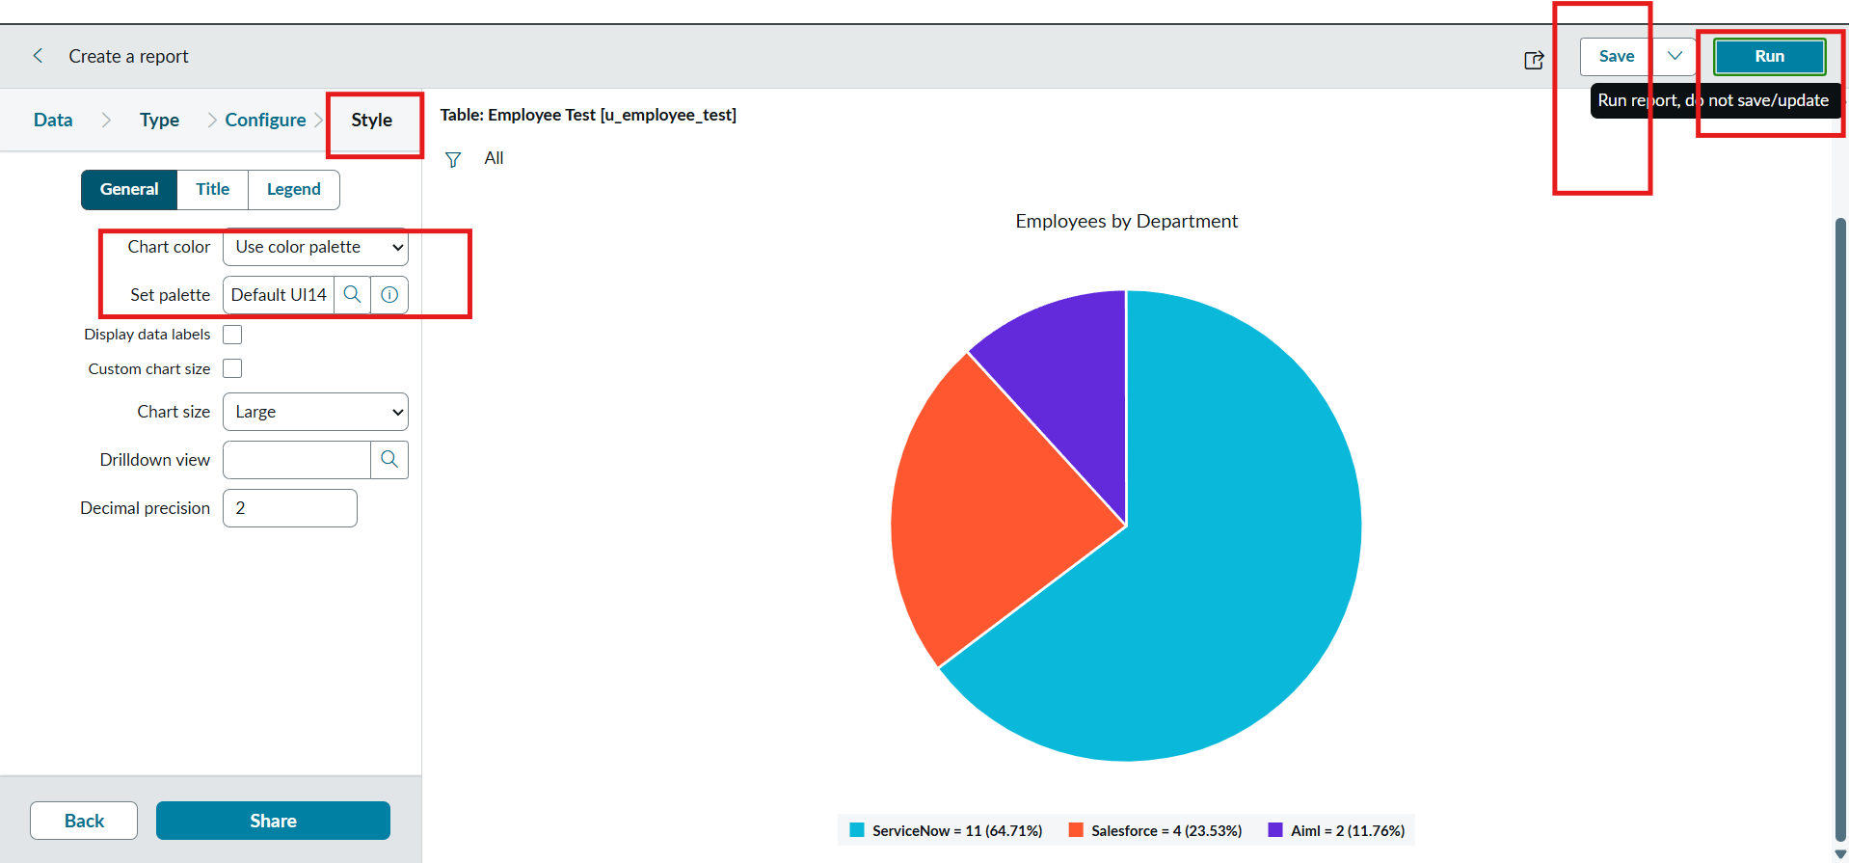
Figure 11
TC-009: Employees by Location bar chart
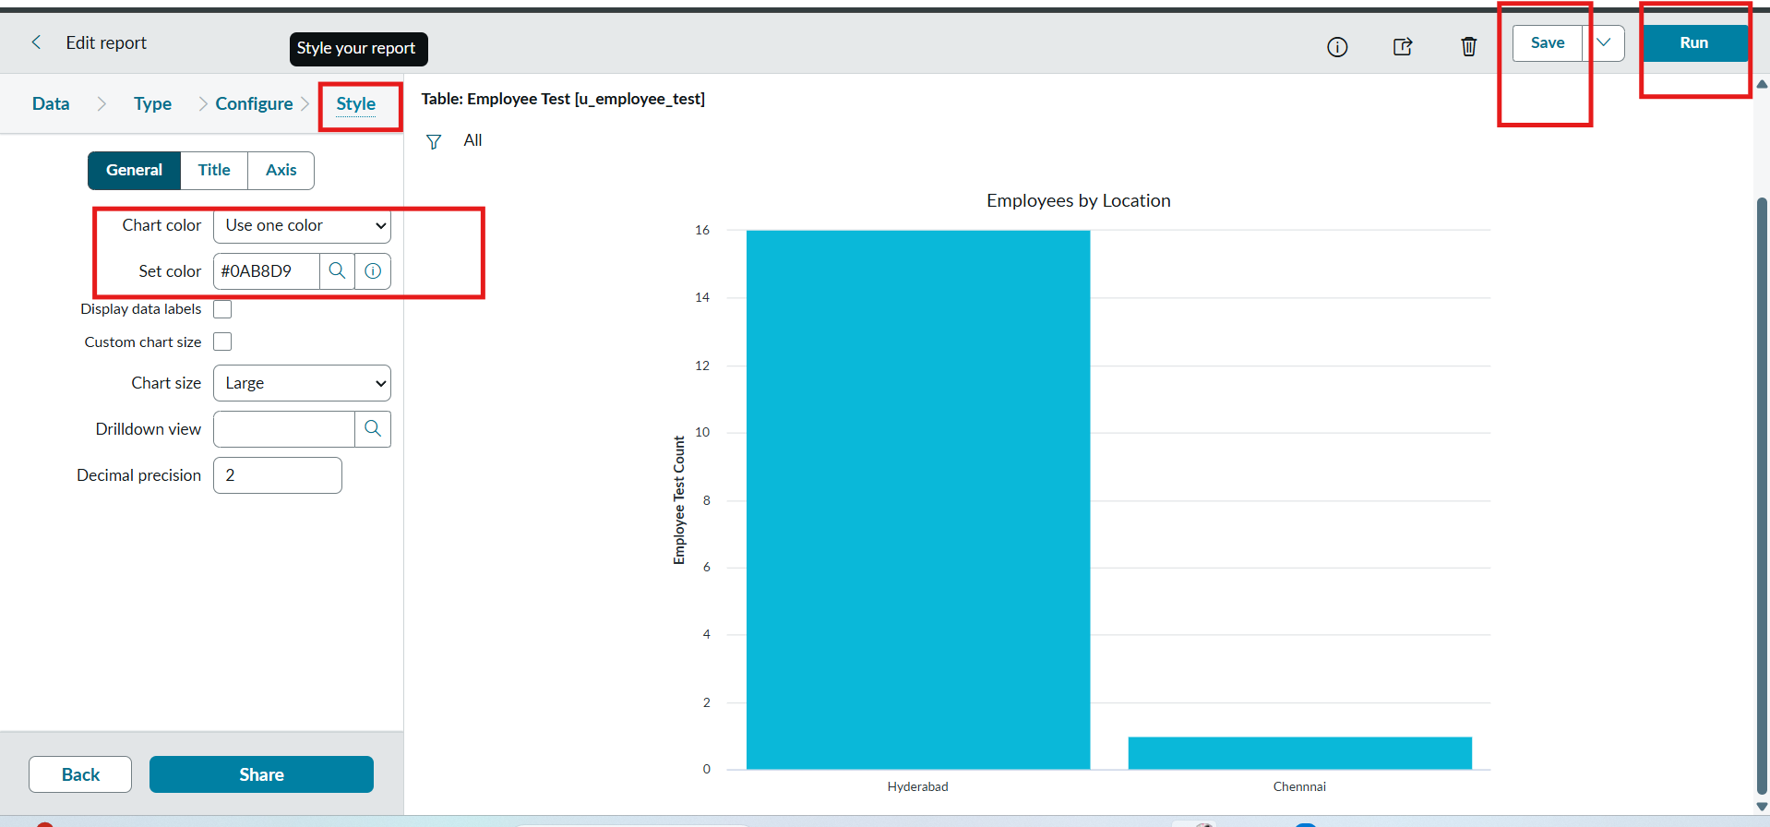
Figure 12
TC-010: Employee List Report
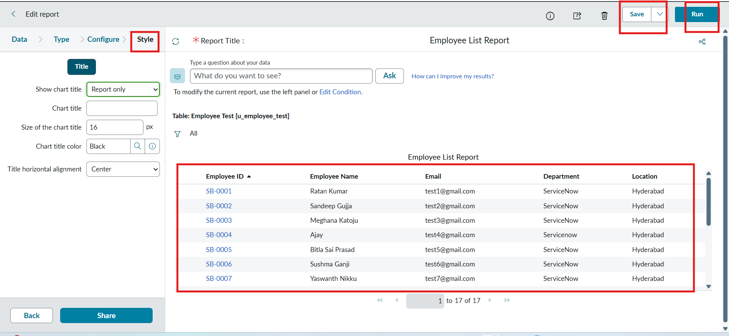
Figure 13
TC-011: Employee Analytics Dashboard with the three reports
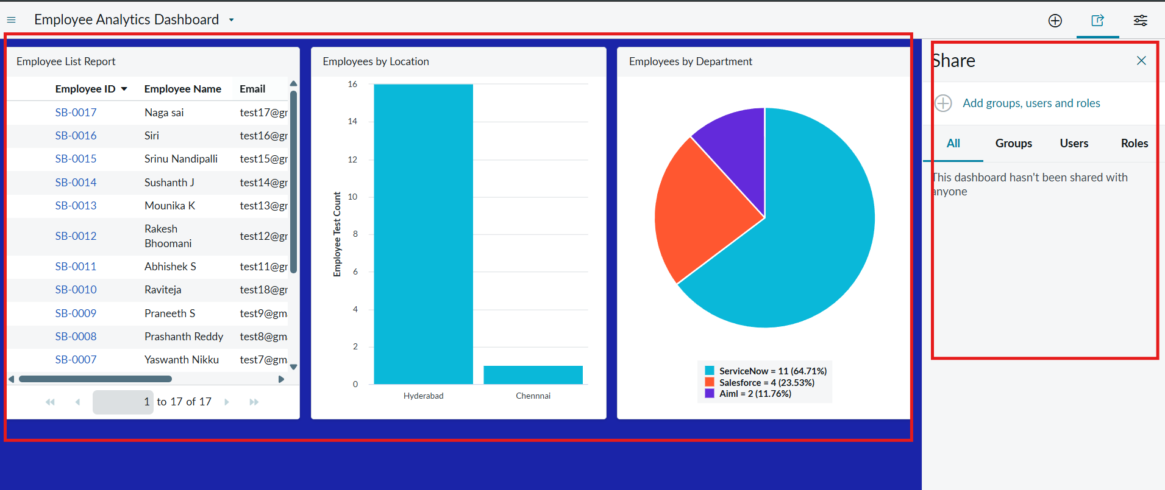
Figure 14

